**Car Rental System**

**Milestone 1 – Code Review 11th September 2024**

***UT Number:***

***(Save file in this format – car_UTNo. eg: car_UT5000)***

**Instructions:**

1. Please use **ONE** file for related HTML, CSS & JavaScript
2. Use **Copy & Paste** for inserting code
3. Question 1
   1. Using the JSON data of members , Display the information shown there by using only the HTML table and associated javascript code.

<< insert screenshot >>



<< Please insert code for Table view from visual studio with black background >>

<!DOCTYPE html>

<html lang="en">

<head>

    <meta charset="UTF-8">

    <meta name="viewport" content="width=device-width, initial-scale=1.0">

    <title>Customer Table</title>

    <style>

       table tr th {

        border: 1px solid black;

        border-collapse: collapse;

       }

    </style>

</head>

<body>

    <table border="">

        <thead>

            <tr>

                <th>Member Id</th>

                <th>First Name</th>

                <th> Last Name</th>

                <th>Date Of Birth</th>

                <th>Image</th>

            </tr>

        </thead>

        <tbody id="memberTableBody" ></tbody>

    </table>

    <script>

        const Members = [

            {

                "id": "M001",

                "firstName": "John",

                "lastName": "Doe",

                "dateOfBirth": "1990-05-15",

                "image": "OIP (5).jpeg"

            },

            {

                "id": "M002",

                "firstName": "Jane",

                "lastName": "Smith",

                "dateOfBirth": "1985-08-22",

                "image": "45464.jpeg"

            },

            {

                "id": "M003",

                "firstName": "Michael",

                "lastName": "Johnson",

                "dateOfBirth": "1992-11-30",

                "image": "OIP (5).jpeg"

            },

            {

                "id": "M004",

                "firstName": "Emily",

                "lastName": "Williams",

                "dateOfBirth": "1995-04-10",

                "image": "OIP (6).jpeg"

            },

            {

                "id": "M005",

                "firstName": "Nelson",

                "lastName": "Mandella",

                "dateOfBirth": "1965-04-17",

                "image": "45464.jpeg"

            }

        ];

        const memberTableBody = document.getElementById('memberTableBody');

        Members.forEach(member =>{

            const row = document.createElement('div');

            row.innerHTML = `

            <td>${member.id}</td>

            <td>${member.firstName}</td>

            <td>${member.lastName}</td>

            <td>${member.dateOfBirth}</td>

            <td><img src ="${member.image}"width="100px"</td>

            `;

            memberTableBody.appendChild(row);

        });

        localStorage.setItem("Members",JSON.stringify(Members));

    </script>

</body>

</html>

* 1. Display the Car Data in GridView using loop ( you can either use flex or grid in CSS)

<< insert screenshot >>

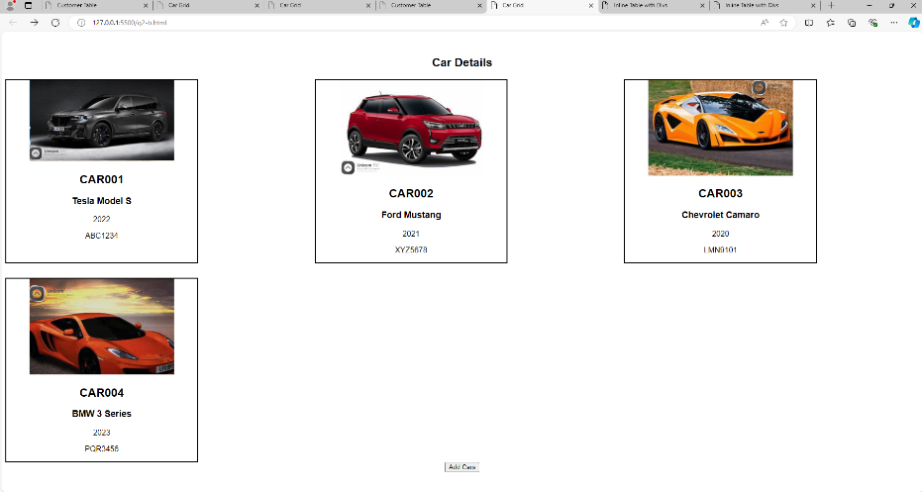

<< Please insert code for Grid view from visual studio with black background >>

<!DOCTYPE html>

<html lang="en">

<head>

    <meta charset="UTF-8">

    <meta name="viewport" content="width=device-width, initial-scale=1.0">

    <title>Car Grid</title>

    <style>

.card{

    border: 2px solid black;

    box-sizing: border-box;

    text-align: center;

    width: 400px;

}

.container{

    display: grid;

    grid-template-columns: 1fr 1fr 1fr;

    gap: 30px;

}

h2{

    text-align: center;

}

    </style>

</head>

<body>

    <h2>Car Details</h2>

    <div class="container" id="carGridView"></div>

    <script>

        const cars = [

            {

                "carId": "CAR001",

                "carName": "Tesla Model S",

                "yearOfManufacture": "2022",

                "registrationNumber": "ABC1234",

                "image": "JUGY.png"

            },

            {

                "carId": "CAR002",

                "carName": "Ford Mustang",

                "yearOfManufacture": "2021",

                "registrationNumber": "XYZ5678",

                "image": "rr.png"

            },

            {

                "carId": "CAR003",

                "carName": "Chevrolet Camaro",

                "yearOfManufacture": "2020",

                "registrationNumber": "LMN9101",

                "image": "r.png"

            },

            {

                "carId": "CAR004",

                "carName": "BMW 3 Series",

                "yearOfManufacture": "2023",

                "registrationNumber": "PQR3456",

                "image":"a.png",

            }

        ];

        const carGridView = document.getElementById("carGridView");

        cars.forEach(car =>{

            const grid = document.createElement('div');

            grid.innerHTML = `

            <img src = "${car.image}" width="300px">

            <h2>${car.carId}</h2>

            <h3>${car.carName}</h3>

            <p>${car.yearOfManufacture}</p>

            <p>${car.registrationNumber}</p>

            `;

            grid.className ="card";

            carGridView.appendChild(grid);

        });

        localStorage.setItem('cars',JSON.stringify(cars));

    </script>

</body>

</html>

1. Question 2
   1. (Using the Modal window given in the code , and by utilizing Q1 -> 1 question , display the member table)
      1. you need to create a form in the modal window and put the SAVE button.

<< insert screenshot >>

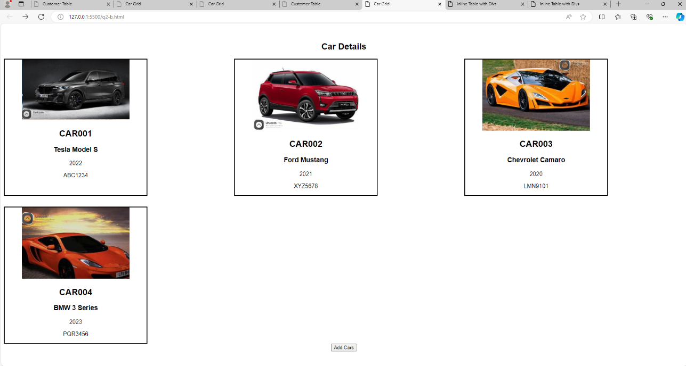

<< Please insert code from visual studio with black background >>

<!DOCTYPE html>

<html lang="en">

<head>

    <meta charset="UTF-8">

    <meta name="viewport" content="width=device-width, initial-scale=1.0">

    <title>Customer Table</title>

    <style>

        /* Basic page styling */

        body {

            font-family: Arial, sans-serif;

            text-align: center;

            margin-top: 50px;

        }

        /* Modal background */

        .modal {

            display: none;

            background-color: rgba(0, 0, 0, 0.5);

            position: fixed;

            z-index: 1;

            left: 0;

            top: 0;

            width: 100%;

            height: 100%;

        }

        /* Modal content */

        .modal-content {

            background-color: #fff;

            margin: 15% auto;

            padding: 20px;

            border: 1px solid #888;

            width: 50%;

            box-shadow: 0px 4px 8px rgba(0, 0, 0, 0.2);

        }

        /* Close button */

        .close-btn {

            color: #aaa;

            float: right;

            font-size: 28px;

            font-weight: bold;

            cursor: pointer;

        }

        .close-btn:hover,

        .close-btn:focus {

            color: #000;

            text-decoration: none;

        }

        /* Modal title */

        .modal-title {

            font-size: 24px;

            margin-bottom: 15px;

        }

        /* Modal body */

        .modal-body {

            font-size: 18px;

        }

        table tr th{

            border: 1px solid black;

            border-collapse: collapse ;

            box-sizing: border-box;

        }

    </style>

</head>

<body>

    <table border="">

        <thead>

            <tr>

                <th>Member Id</th>

                <th>First Name</th>

                <th> Last Name</th>

                <th>Date Of Birth</th>

                <th>Image</th>

            </tr>

        </thead>

        <tbody id="memberTableBody"></tbody>

    </table>

    <button id="openModalBtn">Add Members</button>

    <!-- Modal Structure -->

    <div id="myModal" class="modal"hidden>

        <div class="modal-content">

            <span class="close-btn">&times;</span>

            <h2 class="modal-title">Add Members</h2>

            <div class="modal-body">

                <form action="">

                    <label for="id">Member Id</label>

                    <input type="text" id="memberId"><br>

                    <label for="fname">First Name</label>

                    <input type="text" id="firstName"><br>

                    <label for="lname">Last Name</label>

                    <input type="text" id="lastName"><br>

                    <label for="dob">Date Of Birth</label>

                    <input type="date" id="dateOfBirth"><br>

                    <label for="img">Image</label>

                    <input type="file" id="image"><br>

                    <button type="submit" id="submit">Save</button>

                </form>

            </div>

        </div>

    </div>

    <script>

        const memberTableBody = document.getElementById('memberTableBody');

        const Members = JSON.parse(localStorage.getItem("Members")) || [

            {

                "id": "M001",

                "firstName": "John",

                "lastName": "Doe",

                "dateOfBirth": "1990-05-15",

                "image": "OIP (5).jpeg"

            },

            {

                "id": "M002",

                "firstName": "Jane",

                "lastName": "Smith",

                "dateOfBirth": "1985-08-22",

                "image": "45464.jpeg"

            },

            {

                "id": "M003",

                "firstName": "Michael",

                "lastName": "Johnson",

                "dateOfBirth": "1992-11-30",

                "image": "OIP (5).jpeg"

            },

            {

                "id": "M004",

                "firstName": "Emily",

                "lastName": "Williams",

                "dateOfBirth": "1995-04-10",

                "image": "OIP (6).jpeg"

            },

            {

                "id": "M005",

                "firstName": "Nelson",

                "lastName": "Mandella",

                "dateOfBirth": "1965-04-17",

                "image": "45464.jpeg"

            }

        ];

        Members.forEach(member => {

            const row = document.createElement('div');

            row.innerHTML = `

            <td>${member.id}</td>

            <td>${member.firstName}</td>

            <td>${member.lastName}</td>

            <td>${member.dateOfBirth}</td>

            <td><img src ="${member.image}"width="100px"</td>

            `;

            memberTableBody.appendChild(row);

        });

        const modal = document.getElementById("myModal");

        const openModalBtn = document.getElementById("openModalBtn");

        const closeBtn = document.querySelector(".close-btn");

        const submit = document.getElementById('submit');

        submit.addEventListener('click',(event)=> {

            event.preventDefault();

            const memberId = document.getElementById('memberId').value;

            const firstName = document.getElementById('firstName').value;

            const lastName = document.getElementById('lastName').value;

            const dateOfBirth = document.getElementById('dateOfBirth').value;

            const image = document.getElementById('image').value;

            const newMember ={

                id:memberId,

                firstName:firstName,

                lastName:lastName,

                dateOfBirth:dateOfBirth,

                image:"45464.jpeg",

            };

            Members.push(newMember);

            localStorage.setItem('Members',JSON.stringify(Members));

        })

        openModalBtn.addEventListener("click", () => {

            modal.style.display = "block";

        });

        closeBtn.addEventListener("click", () => {

            modal.style.display = "none";

        });

        window.addEventListener("click", (event) => {

            if (event.target === modal) {

                modal.style.display = "none";

            }

        });

        localStorage.setItem("Members", JSON.stringify(Members));

    </script>

</body>

</html>

* + 1. Once you click save data should be stored inside local storage

<< insert screenshot of local Storage>>

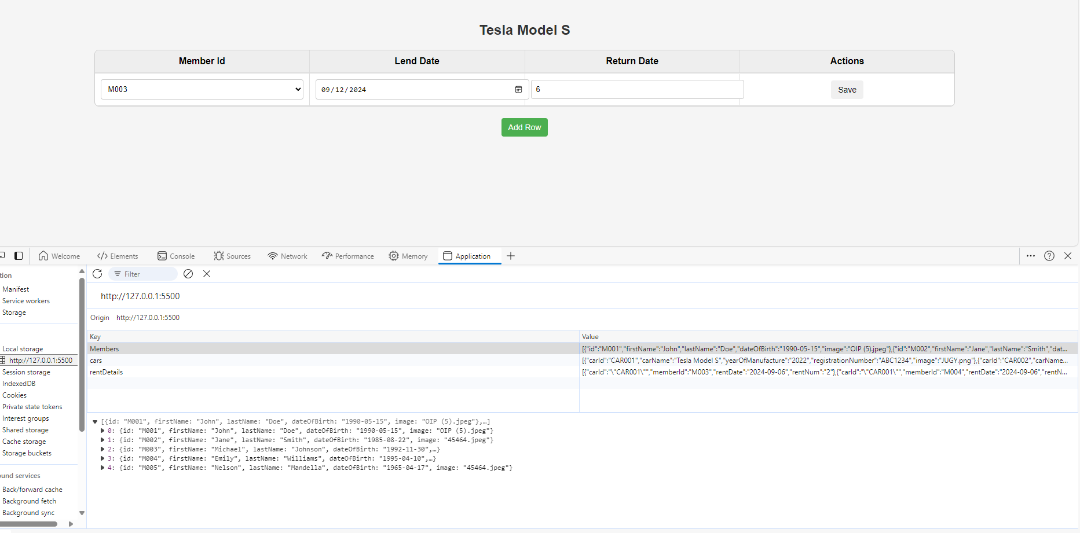

<< Please insert code from visual studio with black background >>

  const Members = JSON.parse(localStorage.getItem("Members")) || [

            {

                "id": "M001",

                "firstName": "John",

                "lastName": "Doe",

                "dateOfBirth": "1990-05-15",

                "image": "OIP (5).jpeg"

            },

            {

                "id": "M002",

                "firstName": "Jane",

                "lastName": "Smith",

                "dateOfBirth": "1985-08-22",

                "image": "45464.jpeg"

            },

            {

                "id": "M003",

                "firstName": "Michael",

                "lastName": "Johnson",

                "dateOfBirth": "1992-11-30",

                "image": "OIP (5).jpeg"

            },

            {

                "id": "M004",

                "firstName": "Emily",

                "lastName": "Williams",

                "dateOfBirth": "1995-04-10",

                "image": "OIP (6).jpeg"

            },

            {

                "id": "M005",

                "firstName": "Nelson",

                "lastName": "Mandella",

                "dateOfBirth": "1965-04-17",

                "image": "45464.jpeg"

            }

        ];

   Members.push(newMember);

            localStorage.setItem('Members',JSON.stringify(Members));

* + 1. and the list of members should be updated.

<< insert screenshot >>



<< Please insert code from visual studio with black background >>

* 1. For the car data , add a modal window to the Q1 -> 2 code ,
     1. add associated form data for cars with a save button.

<< insert screenshot >>

<< Please insert code from visual studio with black background >>

   Members.forEach(member => {

            const row = document.createElement('div');

            row.innerHTML = `

            <td>${member.id}</td>

            <td>${member.firstName}</td>

            <td>${member.lastName}</td>

            <td>${member.dateOfBirth}</td>

            <td><img src ="${member.image}"width="100px"</td>

            `;

            memberTableBody.appendChild(row);

        });

        const modal = document.getElementById("myModal");

        const openModalBtn = document.getElementById("openModalBtn");

        const closeBtn = document.querySelector(".close-btn");

        const submit = document.getElementById('submit');

        submit.addEventListener('click',(event)=> {

            event.preventDefault();

            const memberId = document.getElementById('memberId').value;

            const firstName = document.getElementById('firstName').value;

            const lastName = document.getElementById('lastName').value;

            const dateOfBirth = document.getElementById('dateOfBirth').value;

            const image = document.getElementById('image').value;

            const newMember ={

                id:memberId,

                firstName:firstName,

                lastName:lastName,

                dateOfBirth:dateOfBirth,

                image:"45464.jpeg",

            };

            Members.push(newMember);

            localStorage.setItem('Members',JSON.stringify(Members));

        })

* + 1. once clicked save button , cars data should update inside local storage

<< insert screenshot >>

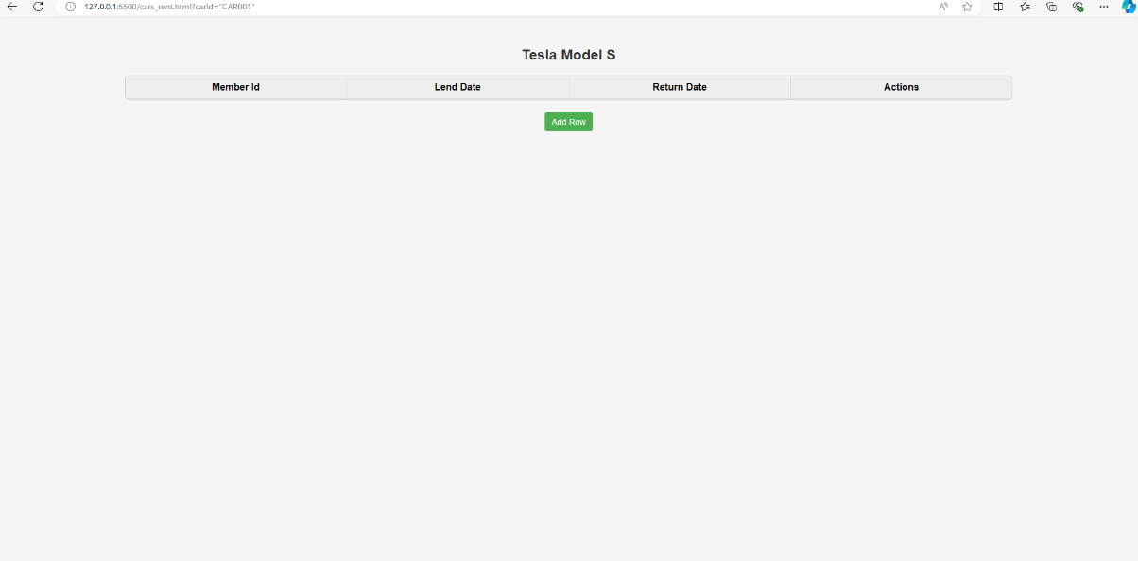

<< Please insert code from visual studio with black background >>

 const newMember ={

                id:memberId,

                firstName:firstName,

                lastName:lastName,

                dateOfBirth:dateOfBirth,

                image:"45464.jpeg",

            };

            Members.push(newMember);

            localStorage.setItem('Members',JSON.stringify(Members));

* + 1. and newly added data should be available in GridView.

<< insert screenshot >>

<< Please insert code from visual studio with black background >>

 Members.forEach(member => {

            const row = document.createElement('div');

            row.innerHTML = `

            <td>${member.id}</td>

            <td>${member.firstName}</td>

            <td>${member.lastName}</td>

            <td>${member.dateOfBirth}</td>

            <td><img src ="${member.image}"width="100px"</td>

            `;

            memberTableBody.appendChild(row);

        });

Question 3 ( Utilizing Q2->2 , once clicked on the car card )

Data structure : [ [ Member , renting date , number of renting days ]

* 1. it should navigate to a page called **cars_rent.html?carId={id}**

<< insert screenshot 1 of URL 1 >>

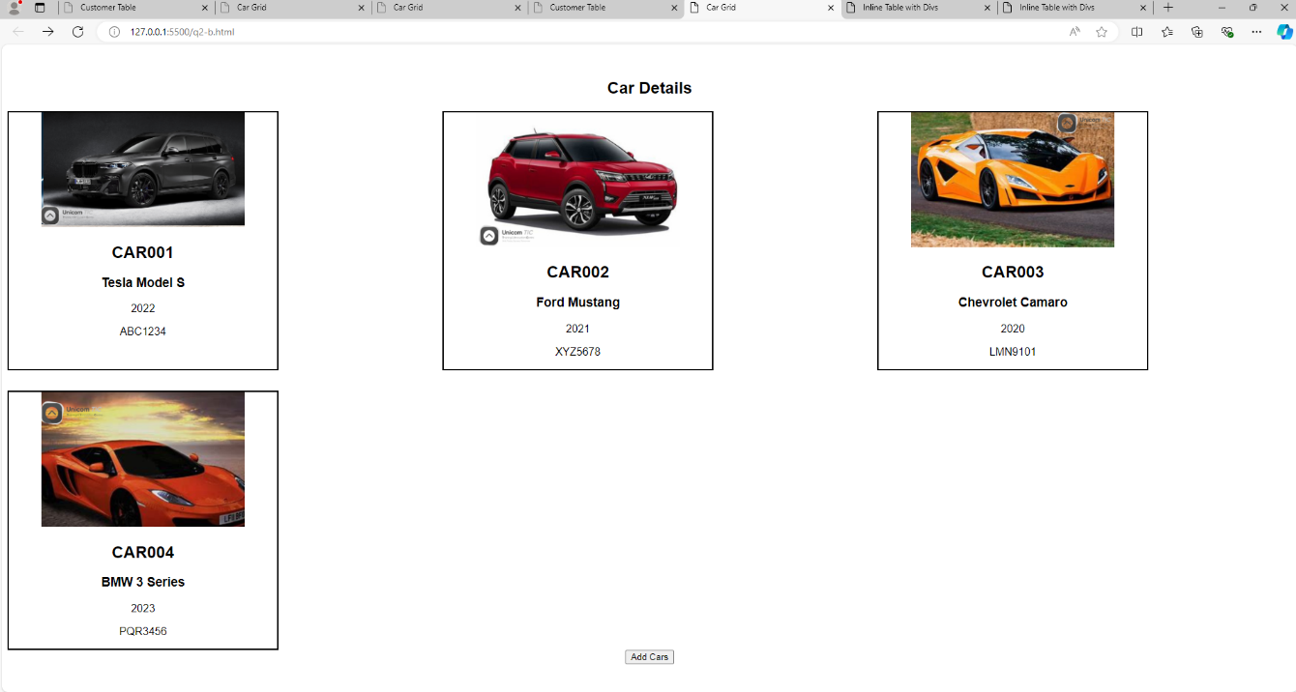

<< insert screenshot 2 of URL 2>>

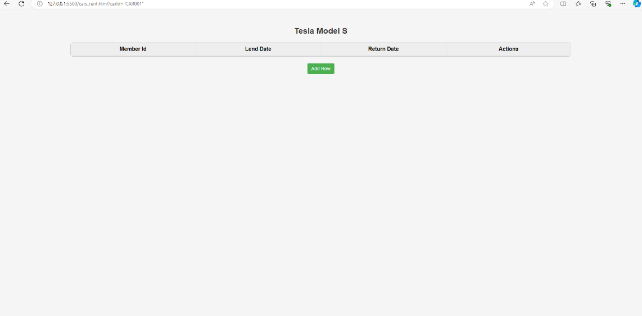

<<Please insert code for to link the above view on the GRID page>>

        grid.onclick = (event)=>{

              window.location.href =`cars_rent.html?carId="${car.carId}"`;

            };

* 1. Introduce a heading CarTile : {carTitle} , it should change according to dynamic carId in url

<< insert screenshot >>

<< Please insert code from visual studio with black background >>

  <h2 id="title-name"></h2>

 const title = document.getElementById('title-name');

        function getQueryParam(param) {

            const urlParams = new URLSearchParams(window.location.search);

            return urlParams.get(param);

        }

        const loadedCarId = getQueryParam('carId');

        const loadedCar = cars.find(

            (car) => car.carId = loadedCarId

        )

        // console.log(loadedCar);

        title.innerHTML = loadedCar.carName;

* 1. on their you have to utilize the inline table given in the code guide and modify associated Column headings and fields

<< insert screenshot >>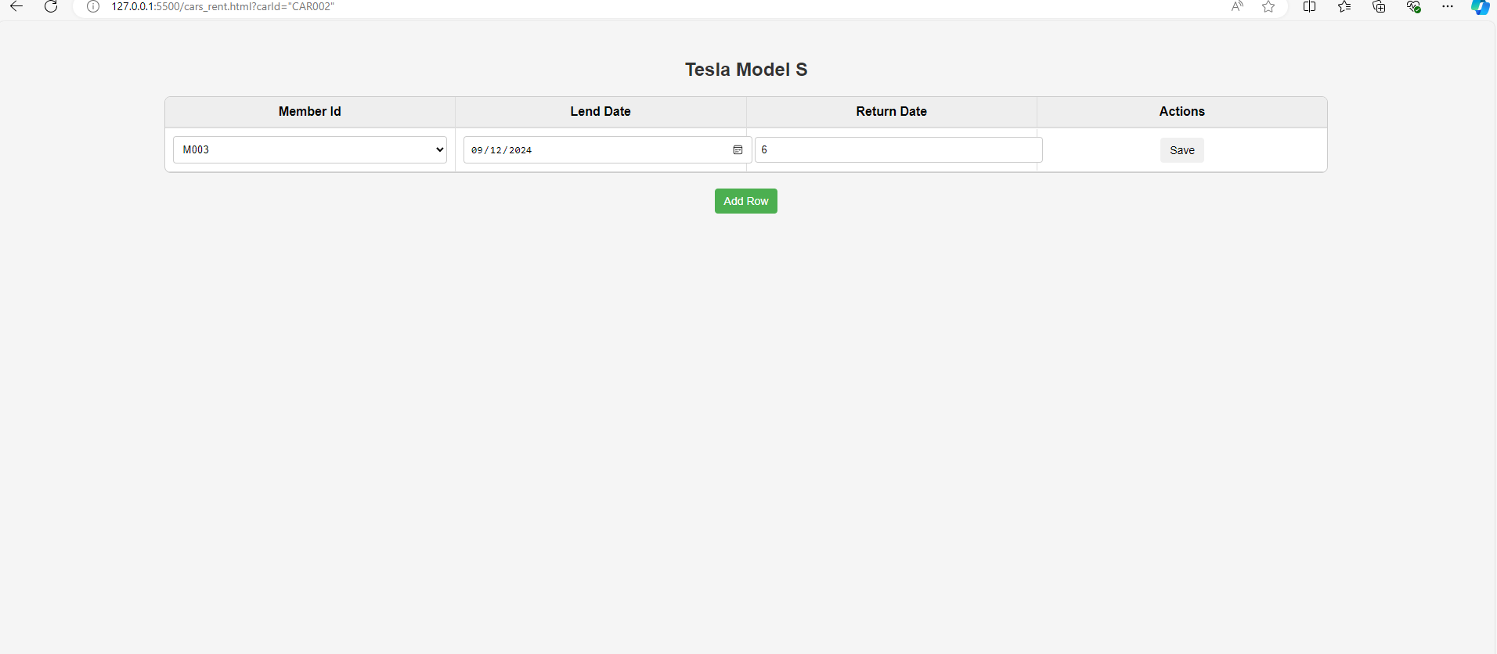

<< Please insert code from visual studio with black background >>

 <div id="table-container">

        <div class="table-header">

            <div class="table-cell">Member Id</div>

            <div class="table-cell">Lend Date</div>

            <div class="table-cell">Return Date</div>

            <div class="table-cell">Actions</div>

        </div>

* 1. you have to associate lending details such as [ Member , renting date , number of renting days ] here Members should populate in dropdown

<< insert screenshot >>

<< Please insert code from visual studio with black background >>

   function showTable() {

            if (loadedCarId == rentDetails.carId) {

                addRowBtn.addEventListener("click", () => {

                    const newRow = document.createElement("div");

                    newRow.classList.add("table-row");

                    // Add columns to the new row

                    newRow.innerHTML = `

                  <div class="table-cell">

                             </div>

                 <div class="table-cell">

                      <input type="date" id="rentDate" value="${rentDetails.rentDate}" readonly/>

                     </div>

                <div class="table-cell">

                     <input type="number" id="rentNum" value="${rentDetails.rentNum}" readonly/>

                     </div>

                 <div class="table-cell">

                     <button class="save-btn">Save</button>

                </div>

                 `;

                    let selectTag = document.createElement('select');

                    selectTag.classList.add('drop-down');

                    let option = document.createElement('option');

                    option.value = rentDetails.memberId;

                    option.setAttribute("readonly", "true");

                    option.innerHTML = rentDetails.memberId;

                    selectTag.appendChild(option);

                    newRow.querySelector('.table-cell').appendChild(selectTag);

                    JSON.parse(localStorage.getItem("rentDetails"));

                    event.preventDefault();

                });

            }

 function saveRow(row) {

            let carId = loadedCarId;

            let memberId = row.querySelector('.drop-down').value;

            let rentDate = row.querySelector('#rentDate').value;

            let rentNum = row.querySelector('#rentNum').value;

            const newRentDetail = {

                carId: loadedCarId,

                memberId: memberId,

                rentDate: rentDate,

                rentNum: rentNum,

            }

            console.log(memberId);

            rentDetails.push(newRentDetail);

            localStorage.setItem('rentDetails', JSON.stringify(rentDetails));

            console.log(rentDetails);

        };

and data should persist to local storage and make sure the data get loaded even after refresh

<< insert screenshot of UI>>

<< insert screenshot of LocalStorage>>

<< Please insert code from visual studio with black background >>